1. Chi-Squared Tests of Independence

In the previous lecture we talked about the odds-ratio test of statistical independence for a 2 ×2 contingency table. For a larger contingency table, some other method is needed. Chi-squared tests of statistical independence supplies this need.

Our null and alternative hypotheses are as follows:

H0: The two variables are statistically independent.
H1: The two variables are not statistically independent.

We will illustrate the method using two variables with two levels each, but the same principles apply for nominal variables with more than two levels. (For a 2 ×2 table, the odds-ratio test is arguably a better choice).

Let two nominal variables be measured on the same sample of N subjects. We can summarize the data as a two-way table of frequencies (cross-classification table), where O_{ij} is the number of cases observed with level i of variable 1 and level j of variable 2. Suppose for example we have measured presence/absence of two symptoms on a set of patients:

Table: Cross-classification Frequencies for Presence/Absence of Two Symptoms
 | Symptom 2
Symptom 1 | Absent | Present | Total
Absent | O₁₁ | O₁₂ | r₁ = O₁₁ + O₁₂
Present | O₂₁ | O₂₂ | r₂ = O₂₁ + O₂₂
Total | c₁ = O₁₁ + O₂₁ | c₂ = O₁₂ + O₂₂ | N = r₁ + r₂

This format is called a cross-classification table or a contingency table. The numbers along the edges (bottom and right), called the marginal frequencies or sometimes the marginals, are the row (r₁ and r₂) and column (c₁ and c₂) totals.

We use the row and column marginal totals to compute the expected frequencies of each cell. Under the assumption of statistical independence, the probability of a randomly selected case falling in cell (i, j) is the probability of falling in row i × the probability of falling in column j . We get this from the multiplication rule for independent events: P(A and B) = P(A) P(B)

We estimate these row and column probabilities from the marginal frequencies of our table. For example, r₁/N estimates the probability of a case falling in row 1, and c₁/N estimates the probability of a case falling on column 1.

The expected frequency of cases falling in cell (i, j) is therefore estimated as follows:

$$E_{\text{ij}}=N\frac{r_{i}}{N}\frac{c_{j}}{N}=\frac{r_{i}c_{j}}{N}$$

Appling this formula produces a table of expected frequencies:

Expected Frequencies for Presence/Absence of Two Symptoms
 | Symptom 2
Symptom 1 | Absent | Present | Total
Absent | $$E_{\text{11}}=\frac{r_{1}c_{1}}{N}$$ | $$E_{\text{12}}=\frac{r_{1}c_{2}}{N}$$ | r₁
Present | $$E_{\text{21}}=\frac{r_{2}c_{1}}{N}$$ | $$E_{\text{22}}=\frac{r_{2}c_{2}}{N}$$ | r₂
Total | c₁ | c₂ | N

If H0 is correct, the observed frequencies should differ by more than is expected by random sampling variability from the expected frequencies. To test this, we measure the discrepancy of observed and expected frequencies using our previous formula:

Pearson$X^{2}=\sum_{\text{All} \text{cells}}{\frac{(O−E)^{2}}{E}}$

Or, more precisely:

Pearson$X^{2}=\sum_{i}{\sum_{j}{\frac{(O_{\text{ij}}−E_{\text{ij}})^{2}}{E_{\text{ij}}}}}$

where, for our example above, summation is over i, j = 1, 2.

Degrees of freedom

The degrees of freedom for this test are:

df = (R – 1) × (C – 1)

where R is the number of rows and C is the number of columns.

The Pearson X² statistic is follows what is called a chi-squared ($χ^{2}$)distribution. It is from this distribution that the test gets the name chi-squared (there is frequent confusion over this subject; people often mistakenly call the Pearson X² test 2 ×2 $χ^{2}$ test.

There is a separate $χ^{2}$distribution for every number of df.

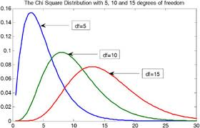

We can compute the p-value of our X² statistic in Excel as:

p = chi dist(X-squared, df)

If p < α (e.g., p < 0.05), we reject H0 and conclude that there is statistical evidence of dependence between the variables. Otherwise we conclude only that we failed to reject the null hypothesis.

Provisos

1. An alternative to the Pearson X² of independence is the Likelihood-ratio chi-squared test, which is denoted as either L² or G². This statistic is computed as follows:

$$L^{2}=2\sum_{i}{\sum_{j}{O_{\text{ij}}\text{ln}\frac{O_{\text{ij}}}{E_{\text{ij}}}}}$$

Like the X² statistic, L² has a chi-squared distribution with (R – 1)× (C – 1) df. Therefore X² and L² usually very close in value (but not identical).

2. The long-range future of the Pearson X² is a little uncertain, due to advances in computing. It is now feasible to use advanced algorithms to test the hypothesis of statistical independence based on the exact probability of observing a given configuration of the table. These algorithms use discrete probability models and consider all possible ways in which, say, N = 100 cases can be distributed among the available cells of a contingency table.

2. Chi-Squared Test of Independence in JMP

Especially with large datasets, it is convenient to store data in the form of a frequency distribution. For example, data on voting preferences of 1000 male and female voters can be summarized by the following table:

Gender | Voting Preference | Frequency
1 | 1 | 200
1 | 2 | 150
1 | 3 | 50
2 | 1 | 250
2 | 2 | 300
2 | 3 | 50
 |  | N = 1000

This format is obviously more efficient than a raw data format with 1000 records

Data are coded as follows:

Gender: 1 = Male, 2 = Female
Preference: 1 = Democrat, 2 = Republic, 3 = Independent

Our null hypothesis is that gender and voting preference are independent.

This time for a change, we will import data directly from an Excel spreadsheet

- File > Open > Files of type > Excel files (browse for voters_frequencies.xls) > click Open
- For Gender and Preference variables: right-click label, then choose for Modeling Type: Nominal
- Highlight all three columns
- Analyze > Fix X by Y
- In pop-up, choose Gender as the X variable, Preference as the Y variable, and Frequency as the 'Freq' variable, and click OK.
- Results will appear in report window beneath mosaic chart.

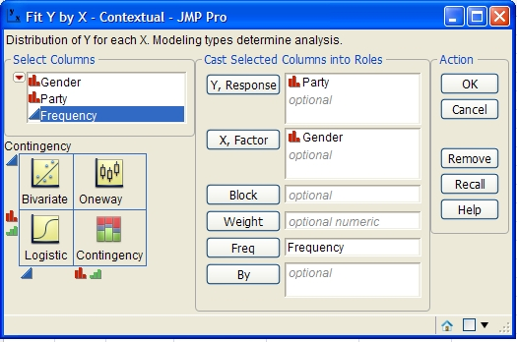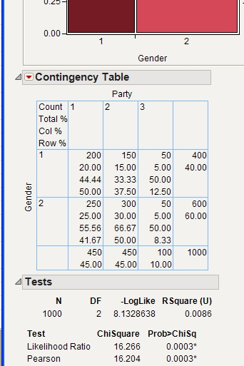
Step 5 Step 6

Pearson X² = 16.2 (2 df), p = 0.0003. Assuming a = 0.01, we would reject the null hypothesis that gender and voting preference are independent.

Homework

Video (optional): Contingency Table Chi-Square Test
http://www.youtube.com/watch?v=hpWdDmgsIRE

